**Exercise 13: Online Bookstore – Unit Testing REST Controllers**

Business Scenario:

Write unit tests for your bookstore's REST controllers using JUnit and Mockito.

1. **JUnit Setup:**

* I set up JUnit and Mockito in my project by adding the dependency in pom.xml file:

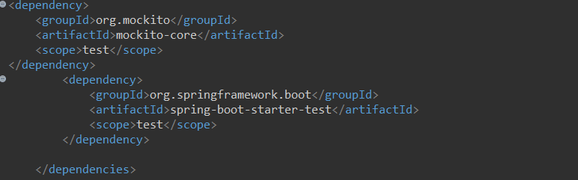

1. **MockMvc:**

* I used MockMvc to write unit tests for my REST controllers:

Unit Testing: we will give a value and we will check whether our API is returning the same value, if the test matches it is successful else not successful.

Under src/test/java:

BookControllerTest.java:

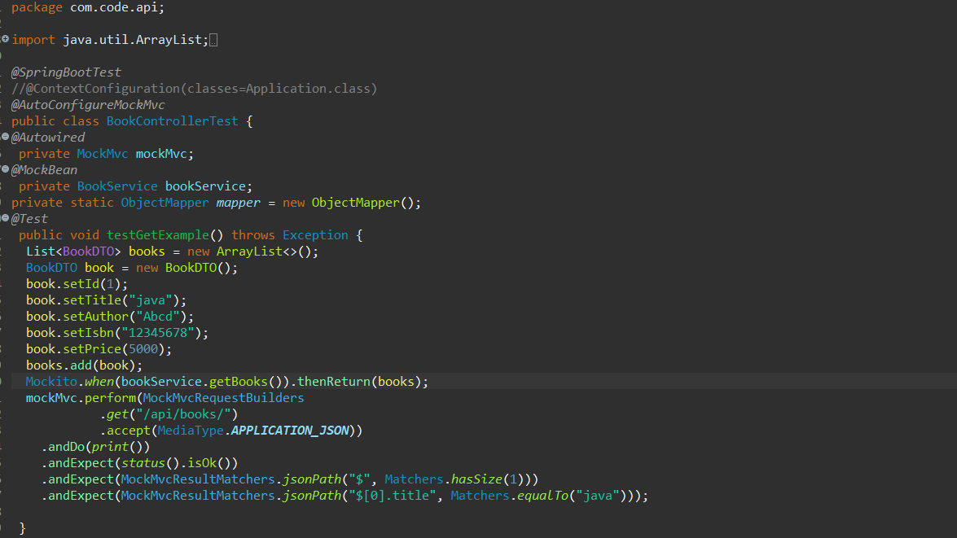

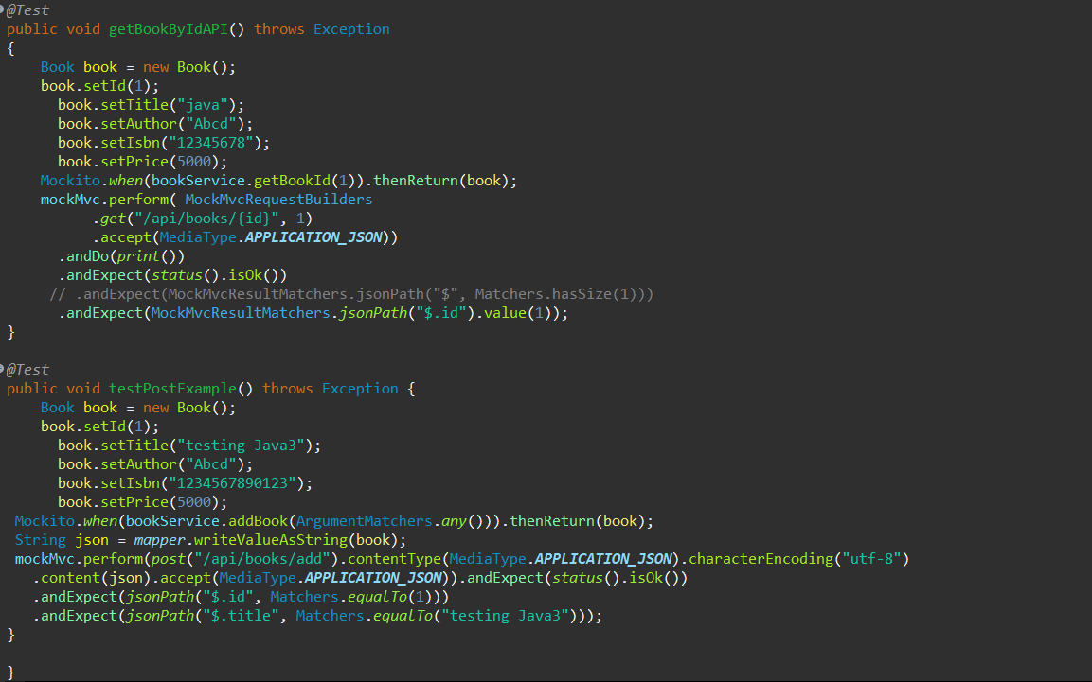

1. **Test Coverage:**

* I ensured comprehensive test coverage and follow best practices for testing.

Console:

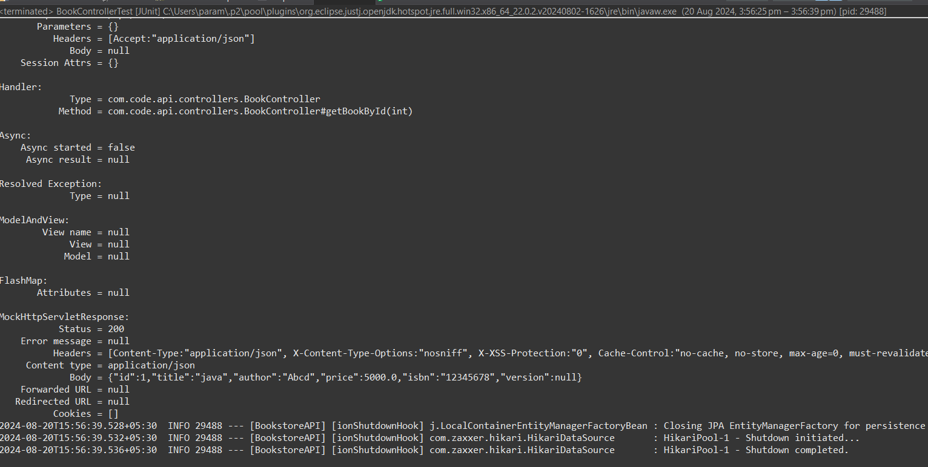

Junit test:

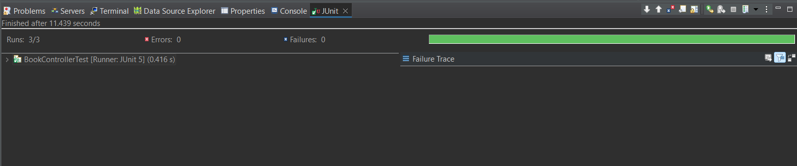

Green shows test successful

Now changing the testing configurations:

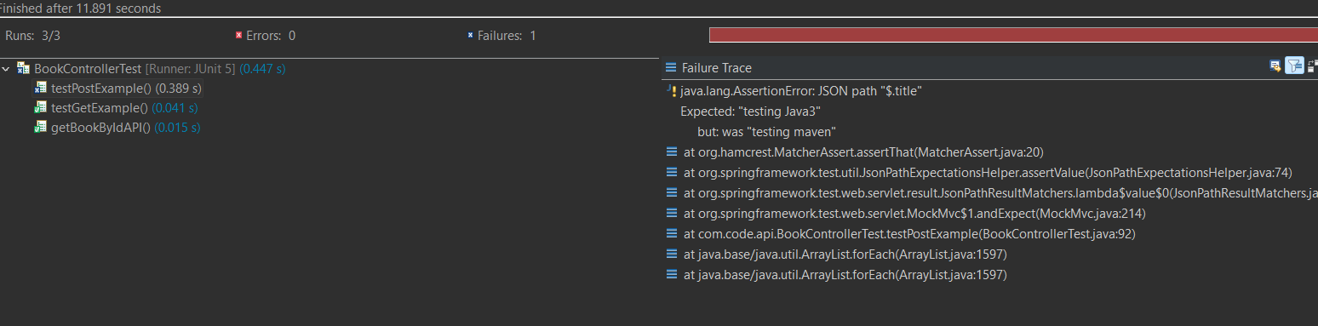

Red shows failure